**Android App Testing Screenshots**

Check-in

Row No.: 24

|  |  |  |  |  |
| --- | --- | --- | --- | --- |
| **Description** | **Test Steps** | **Expected Output** | **Status** | **Comments** |
| Verify character limit for Company Name field | 1. Navigate to visitor check-in page 2. Attempt to enter more characters than allowed in the Company Name field | Company Name field should not accept more than the maximum allowed characters | Fail | Company Name field accepts more than 4000 characters  (Maximum allowed characters limit?) |

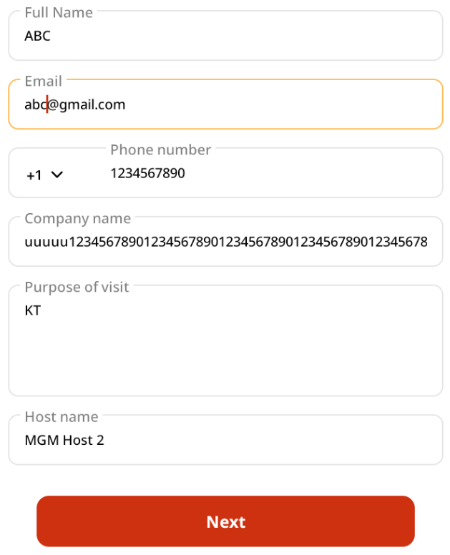

Row No.: 27

|  |  |  |  |  |
| --- | --- | --- | --- | --- |
| **Description** | **Test Steps** | **Expected Output** | **Status** | **Comments** |
| Verify cancellation of check-in process | 1. Start the visitor check-in process 2. Click on cancel/back button at any stage | User should be navigated back to the home/landing page | Fail | User can only click the Back button and navigate to the previous page. It does not navigate to the home/landing page when back button is clicked. |

